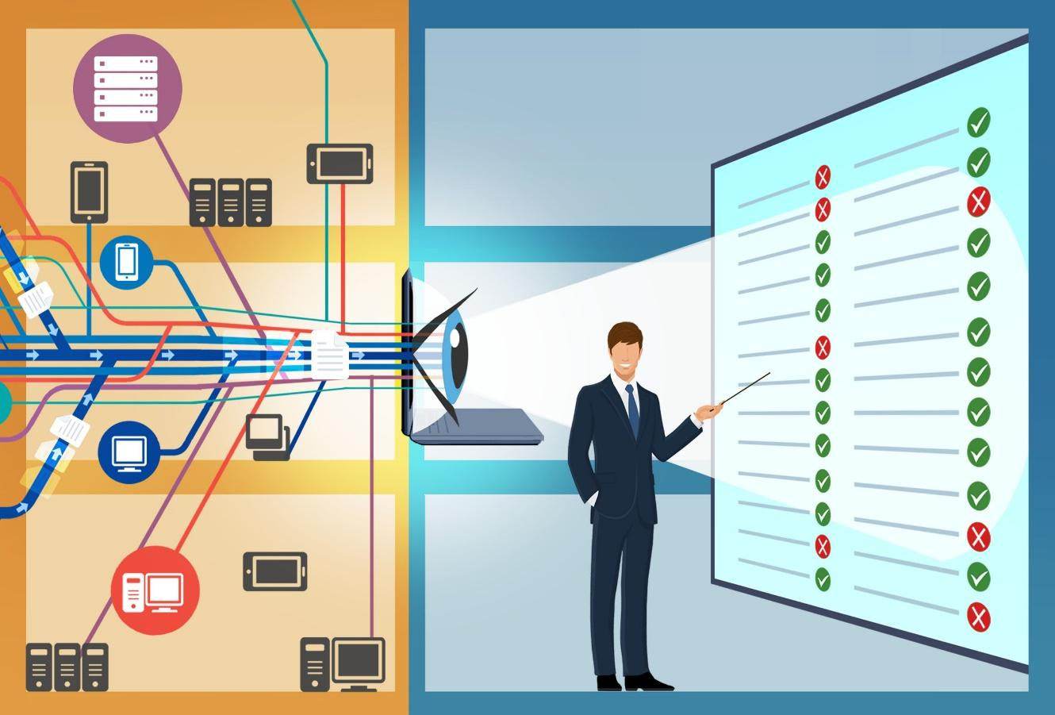


VULNERABILITY ASSESSMENT AND PENETRATION TESTING REPORT

1. Introduction
In this project, I performed a security assessment on a virtual machine called Kioptrix Level 1. The main goal of this task is to find weaknesses in the system and try to exploit them to understand how a real hacker could attack a server. This is a crucial part of "Blue Team" training because we need to know the attack methods to protect the network better.
The environment was set up using VirtualBox. I used Kali Linux as the attacking machine and Kioptrix as the victim. Both machines are in the same local network. The tools I used include Nmap for scanning, Metasploit for attacking, and Wireshark for observing the network traffic.
2. Methodology
I followed the standard penetration testing process, which consists of four main stages:
- Information Gathering: Scanning the target to see which ports are open.
- Vulnerability Analysis: Finding out if the services running on those ports have any known bugs.
- Exploitation: Using a specific tool to take control of the server.
- Post-Exploitation: Verifying the level of access (Root access).

3. Phase 1: Information Gathering (Nmap Scanning)
In this stage, I used Nmap to identify the "face" of the server.

3.1. Service Enumeration
I ran the command: nmap -sS -sV -O -p- 192.168.56.101 <IP Kioptrix>
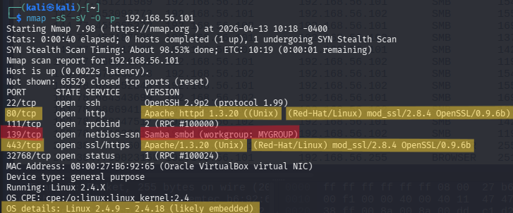
This image shows all 65,535 ports were scanned. We can see port 80 (HTTP), port 139 (NetBIOS), and port 443 (HTTPS) are open.
Port 139/tcp (Samba 2.2.1a): This is the most important line. Samba is used for file sharing, and version 2.2.1a is ancient (from 2001). This version is famous for having "Buffer Overflow" vulnerabilities.
Port 80 (Apache 1.3.20): This release is also an old web server version. It tells us the system is not updated for a long time.
When I saw the result for Samba, I was very surprised because this bug is ancient but still exists in the system. It shows that the administrator did not update the server for over 20 years

4. Phase 2: Vulnerability Analysis
In this stage, I used the Nmap Scripting Engine (NSE) to scan for specific security flaws. This is a crucial step because knowing that a port is open is not enough; we need to know if the service on that port is "broken" or "old." My scan results found many serious problems.

4.1. Web Server SSL/TLS Weaknesses (POODLE and CCS Injection)
I also analyzed the web server running on ports 80 and 443. The results were very bad for the target's security.
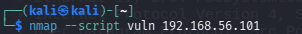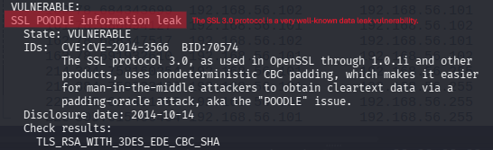
Figure highlights the SSL POODLE vulnerability (CVE-2014-3566).
The POODLE attack (Padding Oracle On Downgraded Legacy Encryption) happens because the server still supports SSLv3. SSLv3 is a very old protocol from many years ago. Hackers can use this to steal "cookies" or session information when a user is browsing the website. If a hacker has your cookie, they can log into your account without a password.
SSL POODLE is like having a strong door but a very weak lock. Even if the door is thick, the hacker can still pick the lock easily.
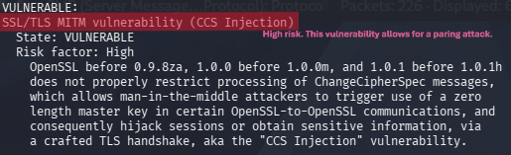
Figure shows the CCS Injection vulnerability.
The scan also found a CCS Injection flaw. This allows an attacker to perform a "Man-in-the-Middle" (MitM) attack. By sending a special handshake message, the attacker can force the server to use a weak encryption key. Subsequently, the attacker can eavesdrop on all the private data exchanged between the user and the server.
4.2. Weak Diffie-Hellman Group
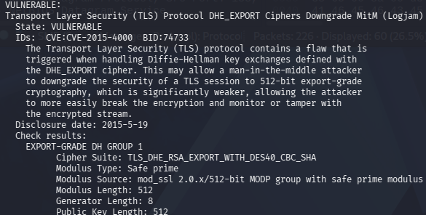
Figure shows the server uses weak 512-bit export-grade cryptography.
The server is using a very weak key exchange method (Diffie-Hellman 512-bit). Modern computers are very fast and can easily break this weak encryption. This is often called the Logjam attack. It means even if the server says the connection is "Secure" (HTTPS), a hacker can still read the messages easily.


4.4. Samba Service Vulnerabilities (CVE-2009-3103)
The most dangerous discovery was in the SMB service.
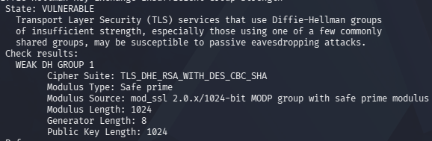
Figure 2 shows that the system is vulnerable to SMBv2 exploits.
The scan identified a critical issue with CVE-2009-3103. This is an "Array index error" in the SMBv2 protocol. This flaw allows a remote attacker to send a specially crafted packet to the server to make it crash (Denial of Service) or, more dangerously, execute arbitrary code. In simple words, a hacker can run any command they want on the Kioptrix server without needing a password.
5. Phase 3: Blue Team Perspective (Wireshark Analysis)
This is where I analyze the network packets to see what actually happens when we scan the system.
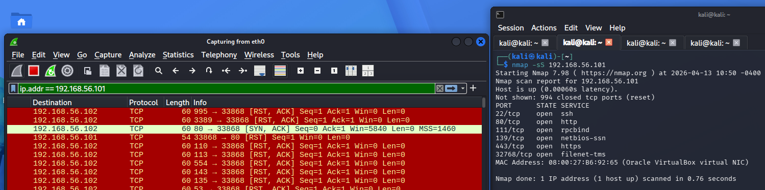
This screen shows the Nmap scan on the right and the Wireshark capture on the left.
Detailed Packet Analysis:
Look at the lines in Red and Light Green in Wireshark:
- The SYN Packet: My Kali machine (192.168.56.102) sends a packet with a [SYN] flag to the Kioptrix server.
- The SYN-ACK Response: The server responds with [SYN, ACK]. This means the port (like port 80) is Open.
- The RST Packet: Instead of completing the connection with an ACK, my Kali machine sends a [RST] (Reset) packet.
- Why is this step important? This is called a Stealth Scan. Because the connection is never fully established, the Kioptrix server might not record this in its application logs. As a Blue Team member, I must look for many "RST" packets in a short time to detect a scanner.

6. Phase 4: Exploitation (Metasploit)
Now, I used Metasploit to exploit the Samba service.
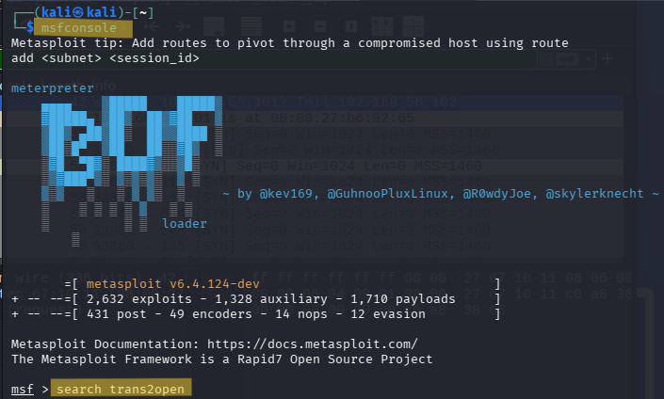
Here i use trans2open to start the attack

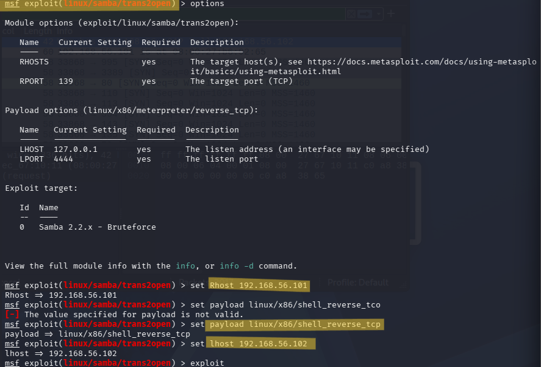
I selected the trans2open module. I set the RHOSTS to 192.168.56.101 and the PAYLOAD to linux/x86/shell_reverse_tcp.
I chose the Reverse TCP Shell. This means the victim machine will connect back to my Kali machine. This is a smart way to bypass some firewalls that block incoming connections but allow outgoing ones.

7. Phase 5: Gaining Root (Proof of Concept)
This is the final result of the attack.
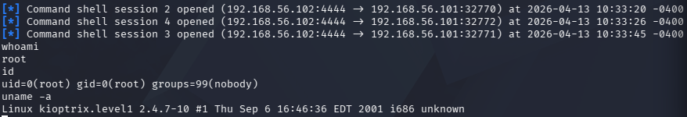
whoami -> root: This confirms I have the highest power on the server.
id -> uid=0(root): In Linux, UID 0 is always the administrator.
uname -a: It shows the kernel is from 2001. This explains why the "Buffer Overflow" attack worked so easily.
8. Conclusion and Final Reflections
In summary, the security assessment of the Kioptrix Level 1 server has been a success. Through the process of reconnaissance, vulnerability scanning, and exploitation, I have identified that the system is extremely weak. The primary reason for this is the use of very old software versions, especially the Samba 2.2.1a service. This specific version allowed me to gain full "root" control over the entire system using the Metasploit Framework. Furthermore, the web server is also at risk because of outdated SSL protocols like SSLv3, which are vulnerable to attacks like POODLE and CCS Injection.
From a personal perspective, this project was a big eye-opener for me as a cybersecurity student. When I first started, I thought that hacking a server would be very difficult and complex. However, I was shocked to see how a simple "Buffer Overflow" bug from 20 years ago could still allow someone to take over a machine so easily today.

